**Lesson 3 Demo 7**

**Commit the Chaincode**

|  |
| --- |
| **Objective:** To check the commit readiness of the chaincode and commit it to a channel  **Tools required:** Ubuntu  **Prerequisites:** Lesson 1 Demo 6 |

Steps to be followed:

1. Checking commit readiness for Org1 and Org2
2. Committing the chaincode definition to mychannel
3. Querying the committed chaincode from mychannel

**Step 1: Checking commit readiness for Org1 and Org2**

1. Run the following command to check commit readiness for Org1:

***peer lifecycle chaincode checkcommitreadiness -C mychannel --name Agrofarm --version 1.0 --sequence 1 --output json --init-required***

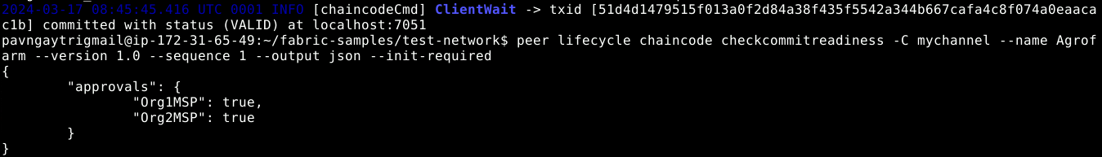

1. Run the following command to check commit readiness for Org2:

***peer lifecycle chaincode checkcommitreadiness -C mychannel --name Agrofarm --version 1.0 --sequence 1 --output json --init-required***

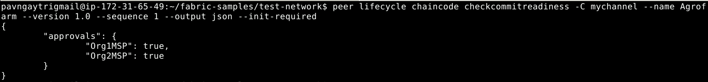

**Step 2: Committing the chaincode definition to samplechannel**

1. Run the following command to create a file for channel commit:***nano lifecycle_setup_Channel_commit.sh***
2. Add the following code to the **lifecycle_setup_Channel_commit.sh** file:

***#!/bin/sh***

***export PATH=${PWD}/../bin:${PWD}:$PATH***

***export FABRIC_CFG_PATH=$PWD/../config/***

***export CORE_PEER_TLS_ENABLED=true***

***export CORE_PEER_LOCALMSPID="Org1MSP"***

***export CORE_PEER_TLS_ROOTCERT_FILE_ORG1=${PWD}/organizations/peerOrganizations/org1.example.com/peers/peer0.org1.example.com/tls/ca.crt***

***export CORE_PEER_TLS_ROOTCERT_FILE_ORG2=${PWD}/organizations/peerOrganizations/org2.example.com/peers/peer0.org2.example.com/tls/ca.crt***

***export CORE_PEER_MSPCONFIGPATH=${PWD}/organizations/peerOrganizations/org1.example.com/users/Admin@org1.example.com/msp***

***export CORE_PEER_ADDRESS=localhost:7051***

***export ORDERER_CA=${PWD}/organizations/ordererOrganizations/example.com/orderers/orderer.example.com/msp/tlscacerts/tlsca.example.com-cert.pem***

1. Run the lifecycle_setup_Channel_commit.sh file using the following command:

***source ./lifecycle_setup_Channel_commit.sh***

1. Run the following command to commit the chaincode definition to samplechannel:

***peer lifecycle chaincode commit -o localhost:7050 --ordererTLSHostnameOverride orderer.example.com --tls $CORE_PEER_TLS_ENABLED --cafile $ORDERER_CA -C mychannel --name Agrofarm --peerAddresses localhost:7051 --tlsRootCertFiles $CORE_PEER_TLS_ROOTCERT_FILE_ORG1 --peerAddresses localhost:9051 --tlsRootCertFiles $CORE_PEER_TLS_ROOTCERT_FILE_ORG2 --version 1.0 --sequence 1 --init-required***

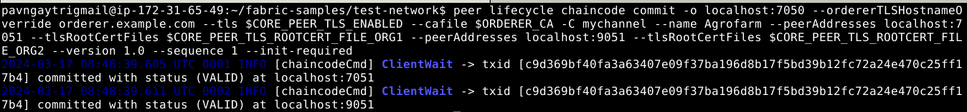

**Step 3: Querying the committed chaincode from mychannel**

1. Run the following command to query the committed chaincode definition from mychannel:

The below command should be run on Org1.

***peer lifecycle chaincode querycommitted -C mychannel --name Carshowroom***

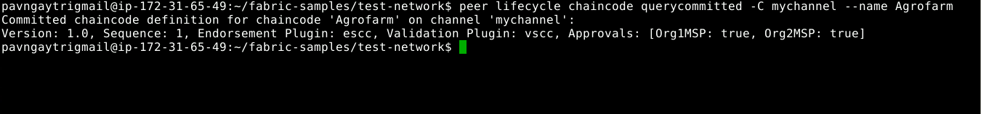

The ***Agrofarm*** chaincode is committed on the channel.